
Christmas Dinner Party
24th & 25th Dec.14 6.30pm

Christmas Present Included πππ

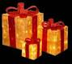

æAsian AtmosphereÆ

Starter

Smoked salmon cream cheese
Tomato mushroom bruchetta
Roast pumpkin soup
Main Course
Roast Turkey & Stuffing

(with cranberry sauce)
or
Chi-Bacon Roll
Pure Vegetarian
or
Mixed Vegetable Rice Bowl
(Mixed vegetables…brown rice ….no dairy)

Served with
Grilled sweet potatoes

Sautéed ginger soya spinach and mushroom
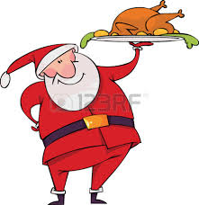
Sesame seed salad, Brown rice
Sautéed vegetables
Bread

Dessert
Christmas cake
Tea or coffee
Complementary one glass of warm wine

Vegetarian – 690 Chickens – 790, Turkey – 1000

De, Vedas Café Restaurant & Bar
Thamel, Kathmandu
Call – 01-4420511

